Synopsys tools design flow.
- Design Compiler (DC)

Invoke command: dc_shell
Execute command: source xyz.tcl

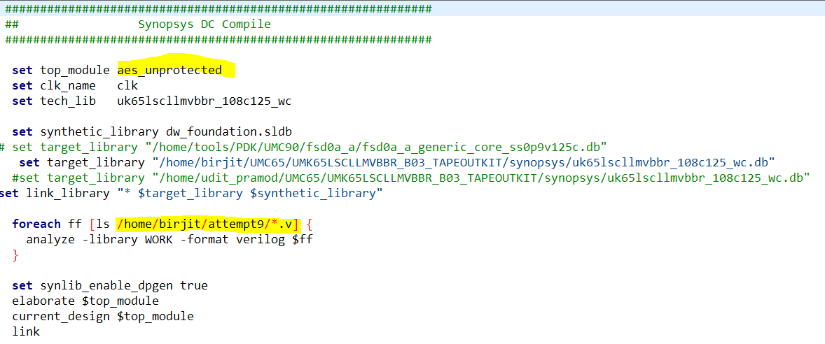

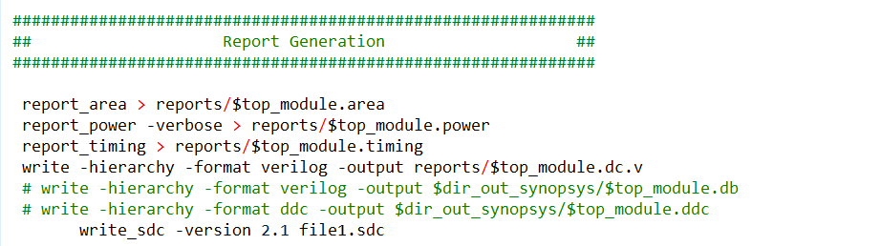

Outputs: area, power and timing reports; netlist.v, sdc (synopsys design constraints) file.

- Formality

Invoke command: formality
Output: No physical output; just verification of the synthesized netlist.

Steps: -
- 1. Ref. Read design files -> Set Top Design
- 2. Impl. Read design files -> Read DB libraries -> Set Top Design
- Match
- Verify

- VCS

Invoke & execute commands:

vlogan -full64 uk65lscllmvbbr_sdf21.v aes_unprotected.dc.v testbench.v
vcs -full64 testbench
./simv

Output: .vcd file

- DVE

Invoke command: dve -full64
Output: No physical output; just post-synthesis functional verification.

- PrimeTime PX

Invoke command: pt_shell
Execute command: source primetimescript.tcl
Output: .fsdb file

- Custom WaveView

Invoke command: wv aes_power.fsdb
Output: No physical output; only waveform viewing.

